

**METU**

**ELECTRICAL AND ELECTRONICS ENGINEERING DEPARTMENT**

**EE463 – Static Power Conversion I**

**Fall 2021-2022**

**Term Project Final Report**

**Judicator Inc.**

**Hüsnü Oğuz YORGANCILAR**  **2305787**

**Ece İrem YAZIR**  **2376101**

**Kaan TÜTEK** **2375954**

**To be submitted to: Assoc. Prof. Ozan KEYSAN**

Table of Contents

Introduction 3

Topology Discussion 3

Simulations 3

Rectifier 3

Buck Converter 6

555 Timer 12

Overall Circuit 14

Component Selection 16

Thermal Analysis 16

Implementation 17

Test Results 23

Cost Analysis 26

References 27

# Introduction

In this report, the simulation results and comments will be explained about the AC-DC converter hardware project. The comparisons and properties about rectifier topology will be shown and simulation results for the chosen topology will be shared. Component selections based on these simulations are explained with the thermal situation of the system that will be used. Finally, the implementation and demonstration results of the project is shared.

# Topology Discussion

|  |  |  |  |  |
| --- | --- | --- | --- | --- |
|  | Vout | Vripple | Number of elements | THD (in the ideal case) |
| 3PCR | $\frac{3\sqrt{6}}{π}$ Vph,rms cosα | $\sqrt{2}$ Vll (1+sinα) | 6 Thyristors + Elements for gate driving + Other passive elements | 31.08% |
| SPCR | $\frac{2\sqrt{2}}{π}$ Vs cosα | $\sqrt{2}$ Vs (1+sinα) | 4 Thyristors + Elements for gate driving + Other passive elements | 48.43% |
| 3PDR | $\frac{3\sqrt{6}}{π}$ Vph,rms | (1- $\frac{\sqrt{3}}{2}$) $\sqrt{6}$ VPH,RMS | 6 Diodes + Other passive elements | 30.27% |
| SPDR | $\frac{2\sqrt{2}}{π}$ Vs | Vs | 4 Diodes + Other passive elements | 48.43% |

Table 1 Topology Comparisons.

The ac-to-dc conversion can be done via four different circuit topologies listed in the above table. In order to have a better signal at the rectifier output, lower ripple voltage is required, so single phase choices are eliminated. Also, comparing the harmonics, we can say that filtering a three-phase source would be a lot easier. For these main reasons, we decided to choose a three-phase rectifier. When it comes to the comparison between a thyristor and a diode topology, we decided to use a diode rectifier since the main problem was to implement many more components for thyristors’ gate drivers. Also, the diode topology was cheaper even with a buck converter than the thyristors and gate driving circuits.

# Simulations

## Rectifier

In this project, it is required to obtain maximum output voltage as 180V. The duty cycle is recommended to be in between 0.2 and 0.8. If it is taken as D= 0.8, required phase voltage rms for three phase diode rectifier can be calculated as follows:

🡪

Diode forward voltage is taken as 1.46V according to the datasheet of the subsequently chosen diode DSEP30-04A. Hence, $V_{s,rms}$ is chosen as 100V considering the non-idealities such as diode forward voltage, and the simulation is performed accordingly. Voltage and current graphs of input, output and rectifier diode are obtained for the circuit in Figure 1 with resistive load R=10Ω.

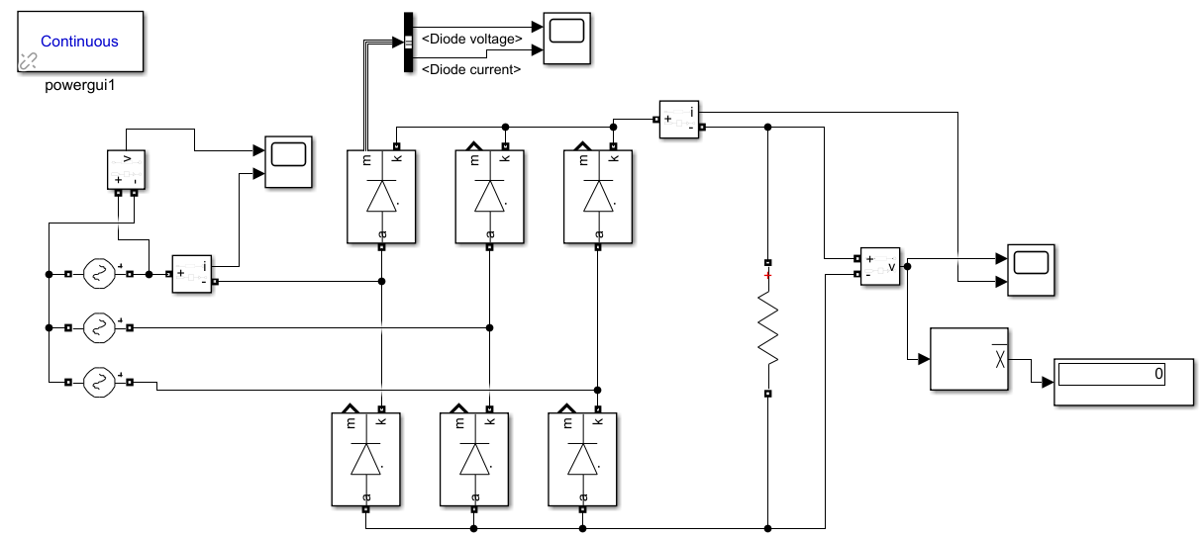

Figure 1. Three-phase full bridge diode rectifier model in Simulink.

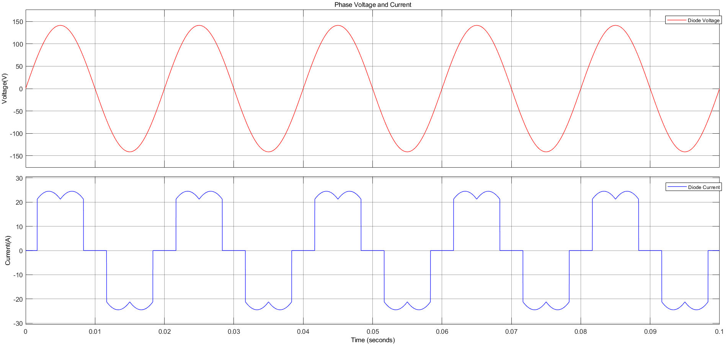

Figure 2. Phase voltage and current waveforms of the rectifier in Simulink.

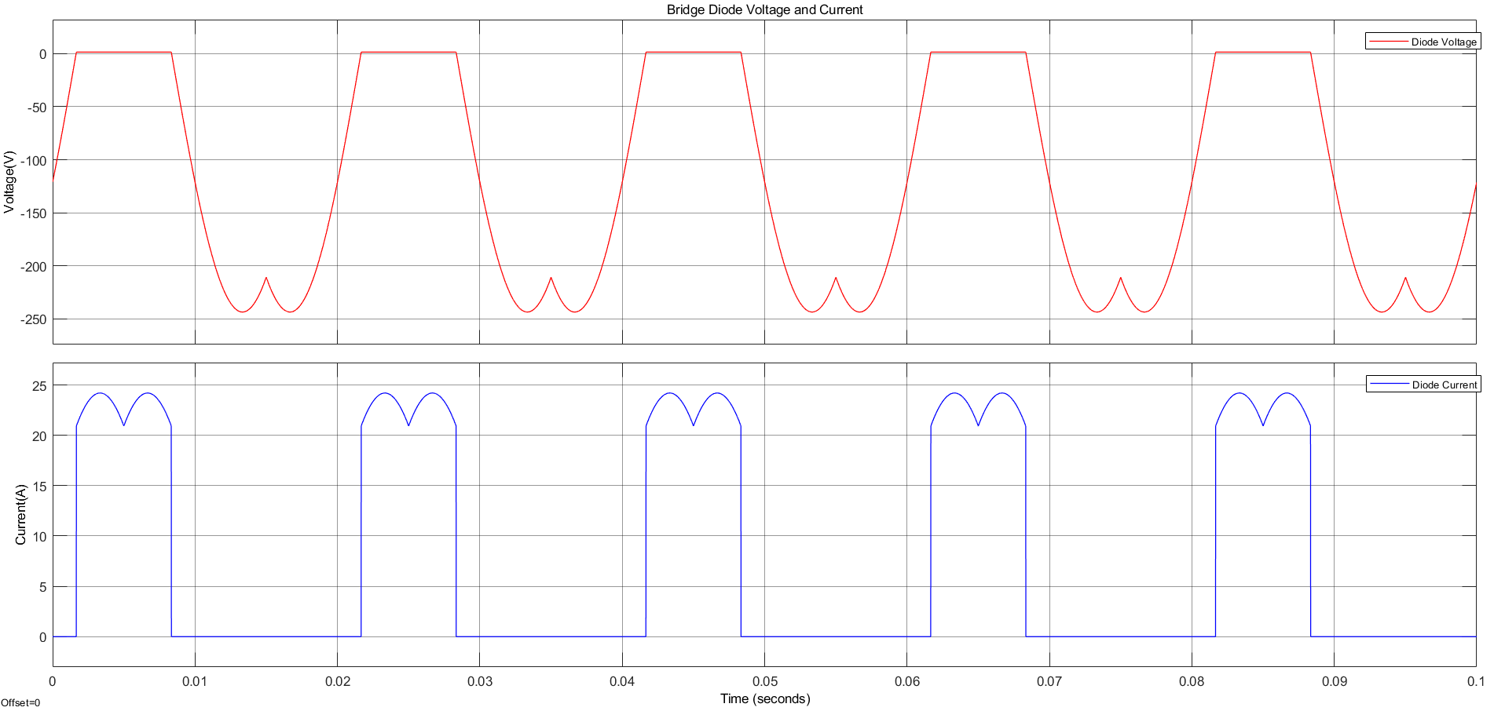

Figure 3. Diode voltage and current waveforms of the rectifier in Simulink.

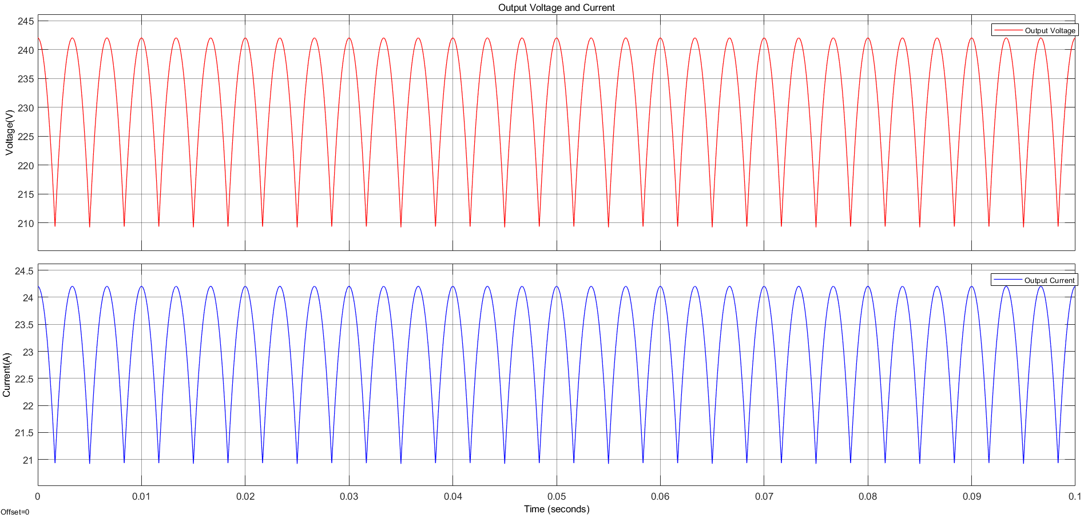

Figure 4. Output voltage and current waveforms of the rectifier in Simulink.

After these, rectifier stage is simulated with line inductance, line resistance, and DC link capacitor. DC link capacitor value was expected to be in the range of 100µF-1000µF. By simulating for selected values which are chosen considering the capacitance values in the market, 470µF is found adequate which gives around 4% output voltage ripple. Also, ESR of the capacitor is included where subsequently selected capacitor has 0.423Ω ESR.

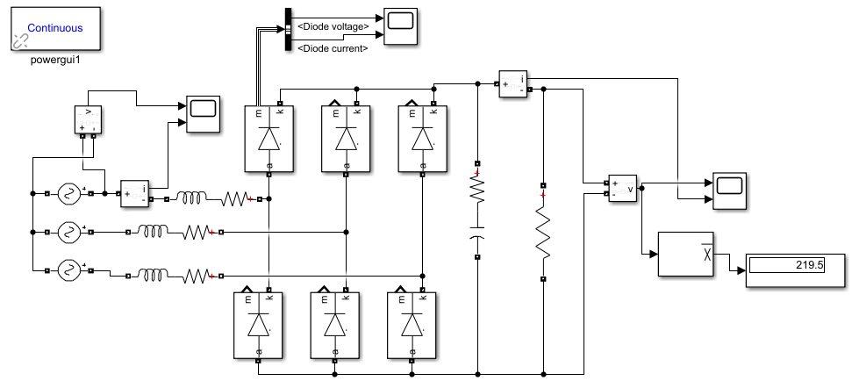

Figure 5. Three-phase full bridge diode rectifier with DC link capacitor model in Simulink.

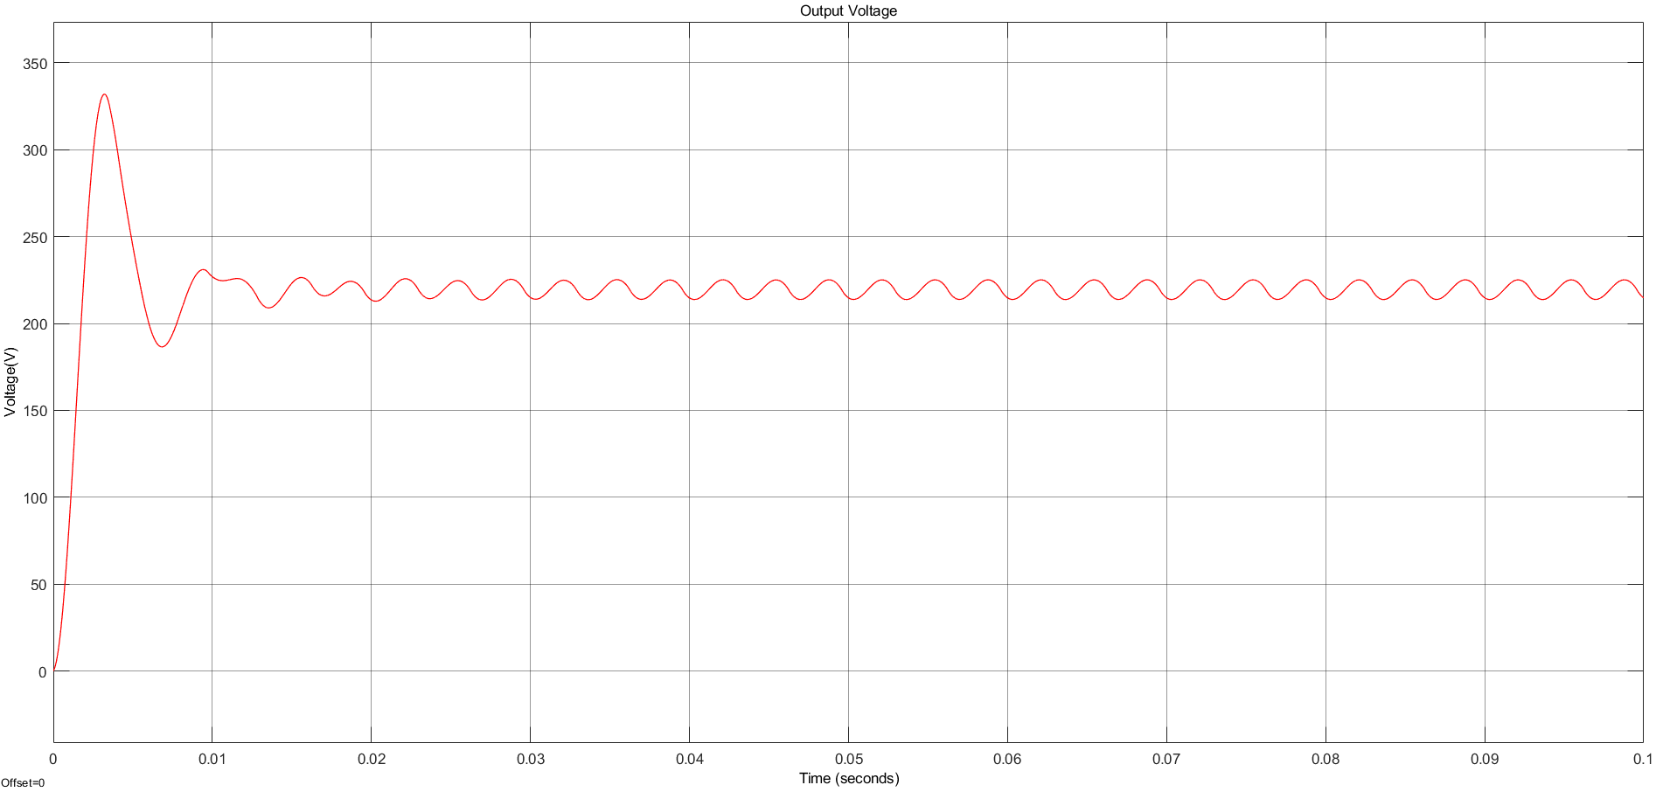

Figure 6. Output voltage waveform of the rectifier with DC link capacitor in Simulink.

## Buck Converter

With the output of the rectifier fed into the buck converter and the output of the rectifier fed into the DC motor with a terminal voltage limit of 180VDC, the relation between the buck converter input and output demands a careful cap on its main control parameter, the duty cycle. Vs,rms will be assigned 100V as was done in the rectifier simulation.

$$V_{out,buck}={D×V}_{in,buck}$$

$$V_{in,buck}=\frac{3\sqrt{6}V_{s,rms}}{π}≅220V_{DC}$$

$$V_{out,buck}=\frac{3\sqrt{6}×D×V_{s,rms}}{π}≤180V_{DC}$$

$$D≤0.7695$$

However, with the addition of an output capacitor, the average output voltage of the rectifier is expected to increase. This increase can be compensated by decreasing the calculated duty cycle. For now, we will limit D at 0.7. This will be monitored with the potentiometers inside the 555 timer topology.

Even so, a duty cycle of 70% could be fatal to the driver circuit during start-up. DC motors have large inrush currents due to the induced emf being speed dependent:

$$E_{a}=K_{a}K_{f}I_{f}ω_{mech}$$

$$I_{a}=\frac{V_{a}-E_{a}}{R_{a}}$$

The low speed of the motor, coupled with the low armature resistance of 0.8Ω, can lead to very high currents. Considering we are allowed to soft-start the motor by manipulating D over time, we will start the circuit with a 10% duty cycle and measure the voltage and current maxima displayed over the components. This will help us simulate the worst-case scenario in terms of currents and determine the limiting metrics. We will replicate the DC motor as an RL branch in series with Ea=0.05V.

The buck converter won’t have an LC filter at its output due to the motor acting as an RL load itself. The switching component was selected to be an IGBT due to its superior current-voltage limits. The input was provided as 220VDC.

The frequency of operation was registered in the pulse generator block as 1kHz. The pulse generator represents the 555 timer output.

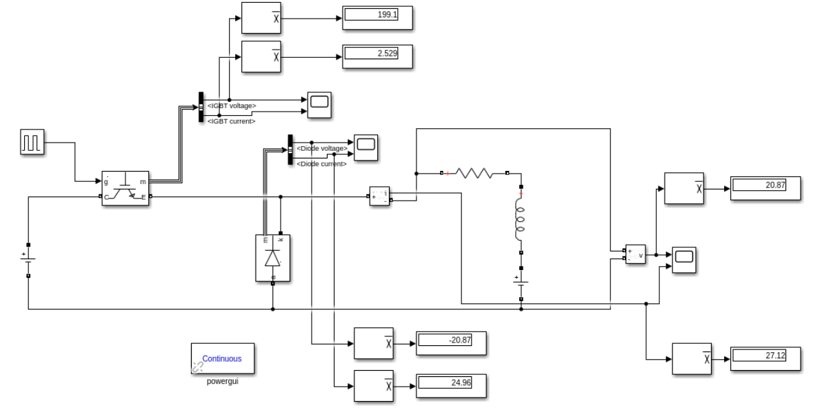

Figure 7. Standalone buck converter model at D=0.1 in Simulink.

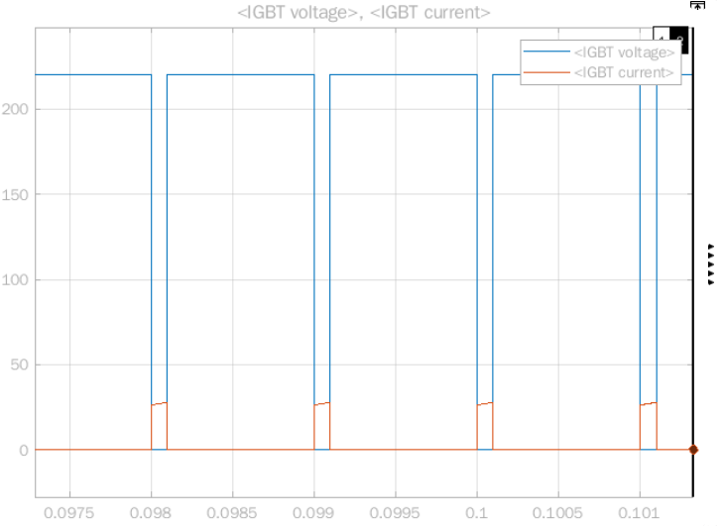

Figure 8. IGBT voltage and current waveforms at D=0.1 in Simulink.

An average voltage of 199.1V and an average current of 2.529A was recorded on the IGBT for D=0.1. Considering Vin * (1-D) is 198V for this duty cycle, the IGBT diode voltage is a value we were expecting. This is because the IGBT voltage is zero during the on period (for an interval of DTs) of the buck converter, and nonzero otherwise.

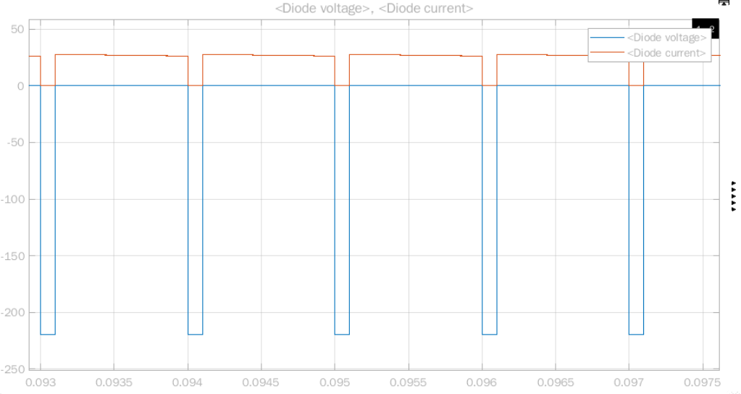

Figure 9. Freewheeling diode voltage and current waveforms at D=0.1 in Simulink.

An average voltage of -20.87V and an average current of 24.96A was recorded on the freewheeling diode for D=0.1. Considering Vin * D is 22V for this duty cycle, the average diode voltage is a value we were expecting. This is because the diode voltage is only zero during the off period (for an interval of (1-D)Ts) of the buck converter, and negative otherwise (reverse-biased).

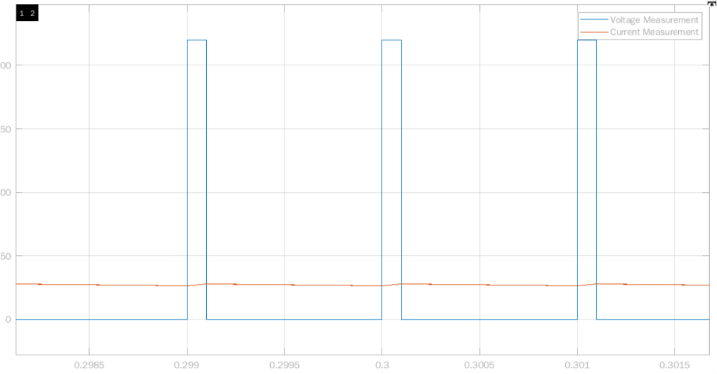

Figure 10. Output voltage (Va) and current waveforms (Ia) at D=0.1 in Simulink.

An average voltage of 20.87V and an average current of 27.12A was recorded on the DC motor for D=0.1. Indeed, this is close to the expected output, at DVin = 22V.

Providing a safety margin of +10%, the set of waveforms for D=0.1 place the following constraints:

|  |  |  |
| --- | --- | --- |
|  | Current rating | Voltage rating |
| IGBT | 3A | 210V |
| Freewheeling diode | 30A | -25V |

Table 2. IGBT and diode voltage and current limits for D=0.1 in Simulink.

It is expected that the IGBT current and diode voltage ratings will have to increase for the D=0.7 simulations, with the increase in the on-time of the circuit.,

With the duty increased to 70%, we will assume the motor has now sped up to its rated value of 1500rpm. For Ea, it was assumed that the constant term KaKfIf = 1, meaning Ea is simply the angular frequency counterpart of 1500rpm, at 157.08V.

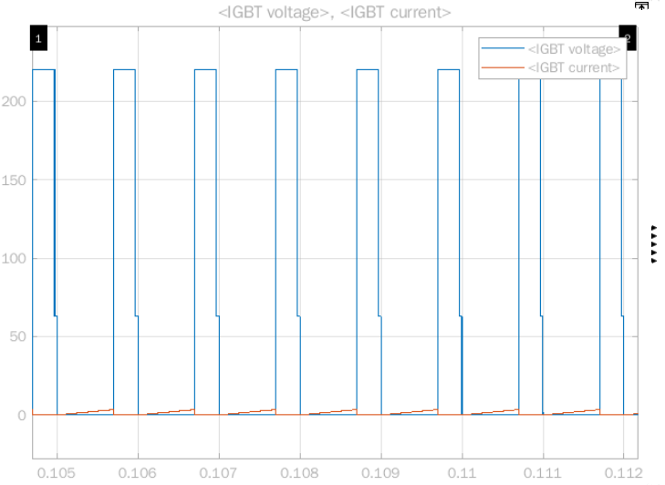

Figure 11. IGBT voltage and current waveforms at D=0.7 in Simulink.

An average voltage of 62.81V and an average current of 0.2552A was recorded on the IGBT for D=0.7. Considering Vin * (1-D) is 66V for this duty cycle, the IGBT diode voltage is a value we were expecting. This is because the IGBT voltage is zero during the on period (for an interval of DTs) of the buck converter, and nonzero otherwise.

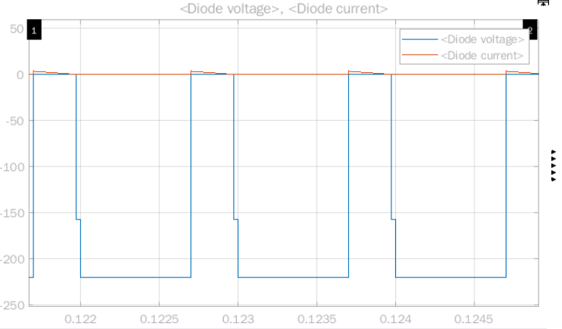

Figure 12. Freewheeling diode voltage and current waveforms at D=0.7 in Simulink.

An average voltage of –157.2V and an average current of 0.9553A was recorded on the freewheeling diode for D=0.7. Considering Vin * D is 154V for this duty cycle, the average diode voltage is a value we were expecting. This is because the diode voltage is only zero during the off period (for an interval of (1-D)Ts) of the buck converter, and negative otherwise (reverse-biased).

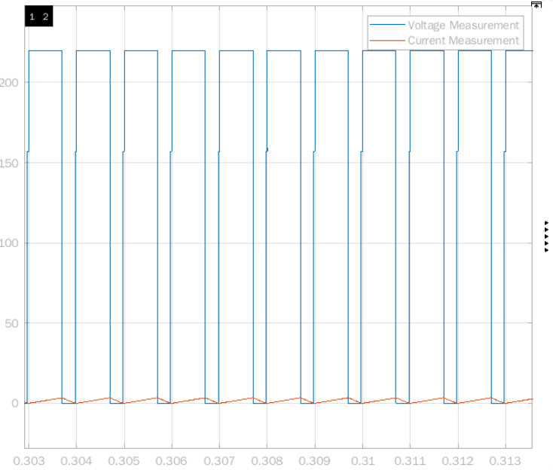

Figure 13. Output voltage (Va) and current waveforms (Ia) at D=0.7 in Simulink.

An average voltage of 157.2V and an average current of 1.687A was recorded on the DC motor for D=0.7. Indeed, this is close to the expected output, at DVin = 154V.

The set of waveforms for D=0.7 place the following constraints:

|  |  |  |
| --- | --- | --- |
|  | Current rating | Voltage rating |
| IGBT | 0.5A | 65V |
| Freewheeling diode | 1A | -160V |

Table 3. IGBT and diode voltage and current limits for D=0.7 in Simulink.

Presumably due to the assumption made on the motor emf constants, the armature current appears quite low. Naturally this affects the IGBT and diode currents. This seeming low current limit need not compromise our component selection, since the relatively worse-case scenario was already simulated for start-up conditions.

Taking the maximum ratings for the IGBT and the freewheeling diode for both of the simulated cases,

|  |  |  |
| --- | --- | --- |
|  | Current rating | Voltage rating |
| IGBT | 3A | 210V |
| Freewheeling diode | 30A | -160V |

Table 4. Anticipated IGBT and diode voltage and current limits.

## 555 Timer

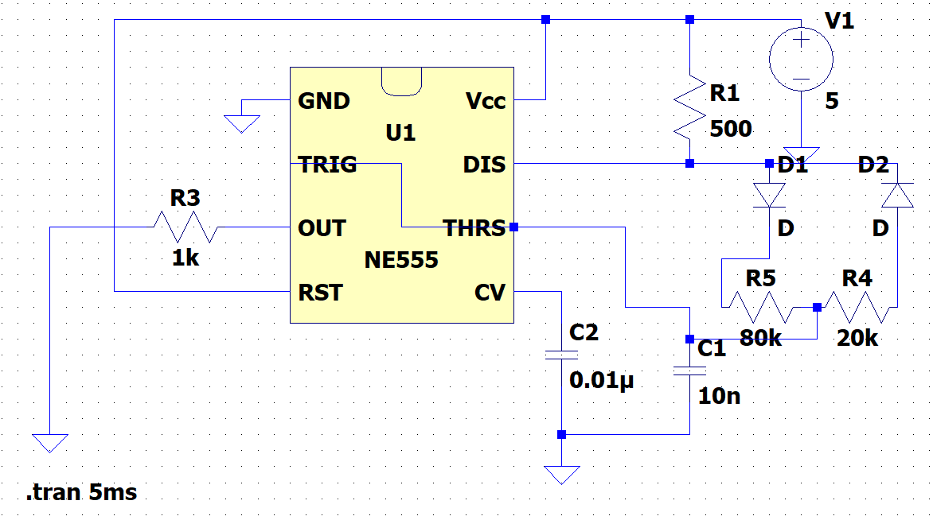

Figure 14. 555 Timer model in LTspice.

We have decided to use LM555 as a controller IC to drive the IGBT. This IC can produce constant frequency PWM signals when used in the configuration shown in Figure 14. Here, R4 and R5 represents a potentiometer. Two diodes are necessary for constant frequency operation. As an input, 5V will be supplied to the IC. The capacitor connected to the Threshold pin (C1) and potentiometer determine the frequency of the PWM signal at the Output pin. Moreover, duty cycle is controlled by changing R5 and R4 ratio where D≈R5/(R4+R5) where R1 is comparatively small [1].

It is known that LC filter size can gets smaller as the frequency increases, however, we do not plan to use LC filter in our circuit since the load is a motor, which can be interpreted as an LCR combination. On the other hand, high frequency increases the switching losses of components such as diode or IGBT, which increases also heatsink size. So, it is decided to use 1kHz frequency considering high frequency losses. In this configuration, frequency formula is f≈1/[(R4+R5)*C1], so potentiometer value is selected as 100kΩ and capacitor is selected as 10nF, yielding 1kHz theoretically. However, this frequency is affected by other components and obtaining exactly 1kHz is not simple. Fortunately, this is not critical for our circuit considering frequency is obtained as 1.07kHz in the simulation which is a close value to the desired frequency. Output voltages are obtained as seen in Figure 15, 16, 17 for 3 different duty cycle, D=0.2, D=0.5 and D=0.8, and theoretical duty cycles and simulated duty cycles are very close.

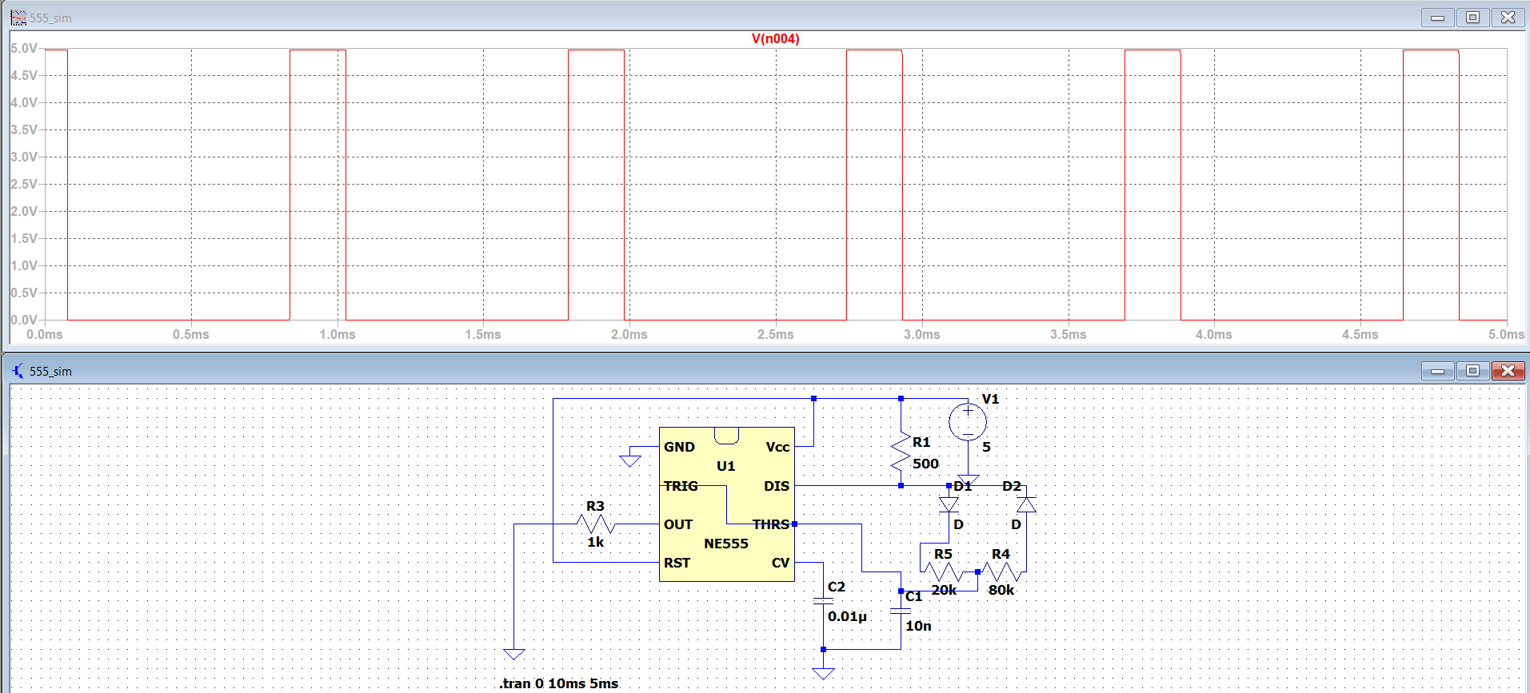

Figure 15. 555 Timer output voltage when D=0.2 in LTspice.

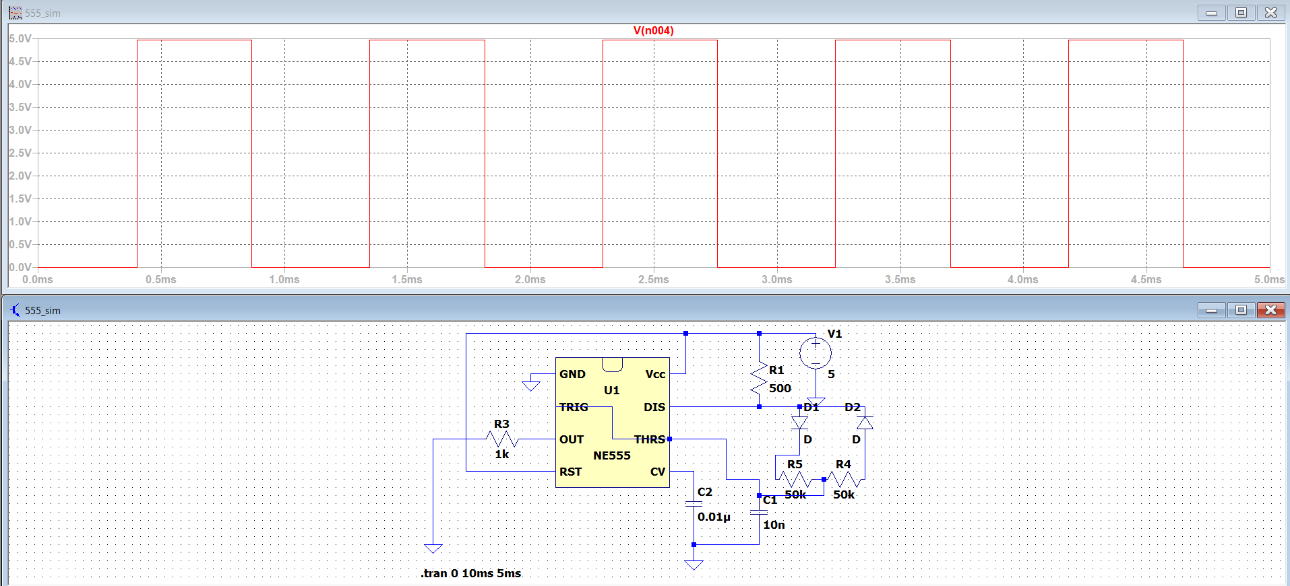

Figure 16. 555 Timer output voltage when D=0.5 in LTspice.

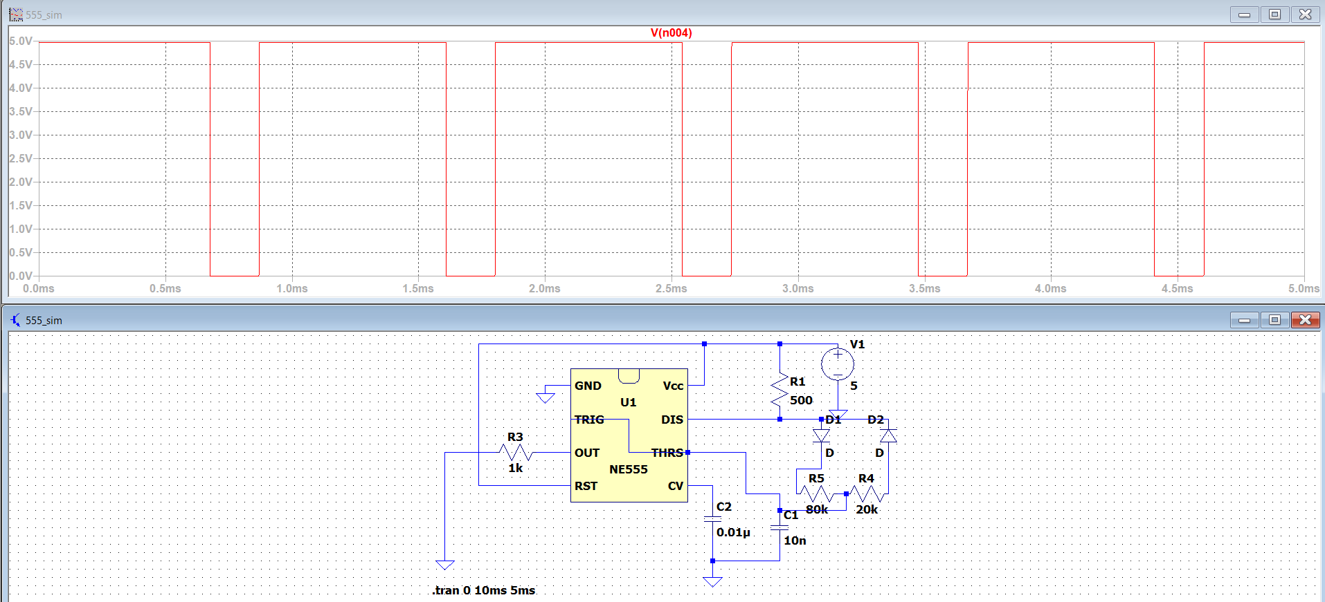

Figure 17. 555 Timer output voltage when D=0.8 in LTspice.

## Overall Circuit

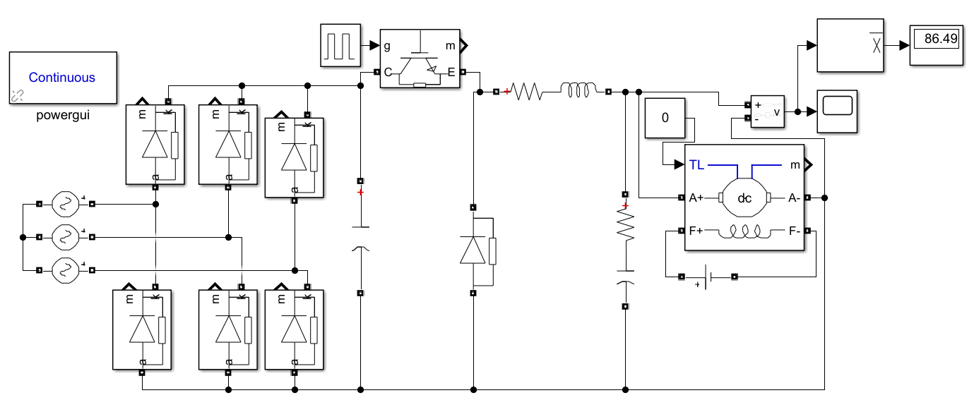

Figure 18. Overall Circuit Simulation Schematic.

With an input peak voltage of 100 volts, the almost ideal circuit simulated in MATLAB with hypothetical inductance and capacitance values gave us an average output of 173 volts with no load.

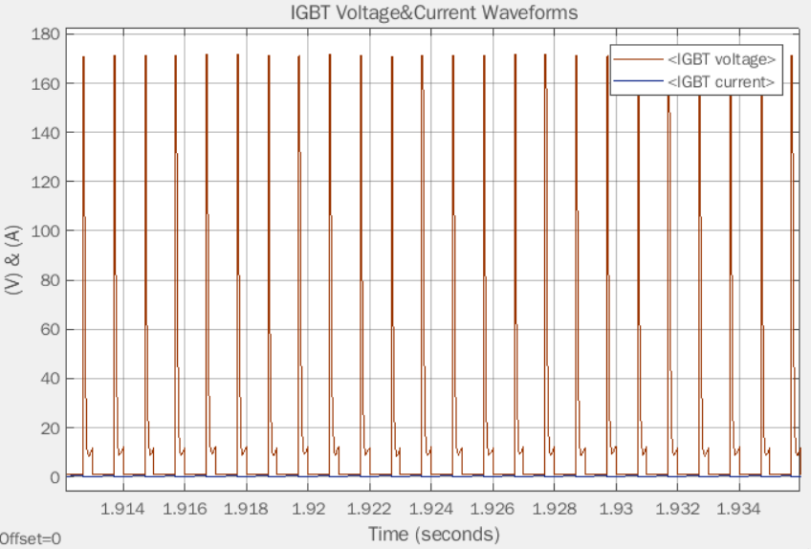

Figure 19. IGBT Current and Voltage

The IGBT component that we use for switching created a meager current rating in the steady state, as seen previously, and component selections will be made accordingly.

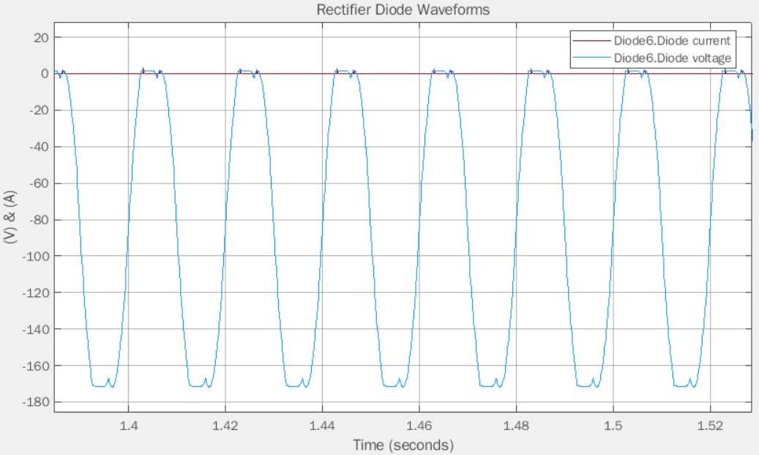

Figure 20. Diode Current and Voltage in SS

Just like the IGBT diodes in the rectifier part have low current ratings as well. This will affect the component selection.

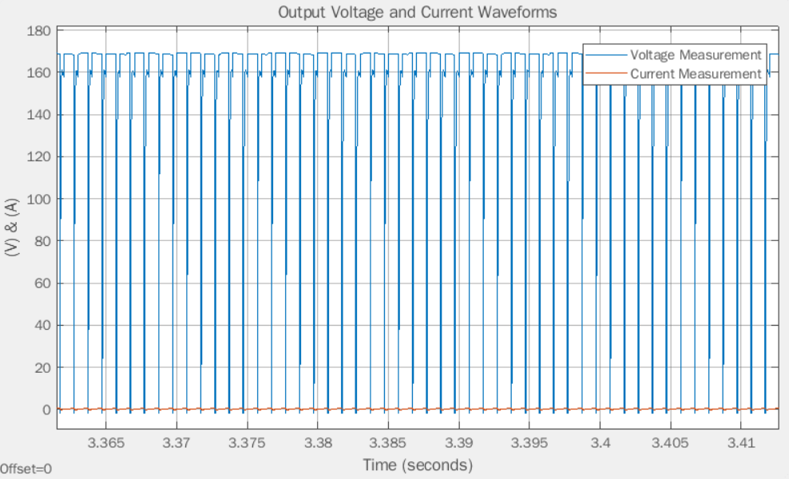

Figure 21 Output Voltage and Current of the 3PDR+Buck Topology

# Component Selection

Generally, we have tried to choose components from the lab inventory since it is easier to replace them if a problem occurs. First, LM555 is chosen as PWM controller due to its simplicity. To isolate LM555 from the power side, optocoupler should be used and TLP250 isolated gate driver optocoupler is chosen for this purpose as it has sufficient isolation voltage for this application. To supply LM555, 5V input is given by the power supply in the lab. Also, that supply voltage is connected to ROE-0512S DC/DC isolated converter giving 12V isolated output which is supplying TLP250.

In addition to these, transistor for the buck converter is chosen as IXGH24N60C4D1 according to the simulation results, which is an N-channel IGBT with 24A 600V rating. By simulation again, safe ratings of rectifier stage diodes and free-wheeling diode are around 30A 300V. Also, we switched from stripboard to PCB, hence, FUO22-12N is selected as a three-phase diode bridge due to its relatively small dimensions and having 30A 1200V rating. 45AS25 model heatsinks are attached to free-wheeling diode and IGBT and a bigger heatsink is used for diode bridge according to the calculations of thermal analysis.

Moreover, as explained in Simulations-Rectifier part, DC link capacitor is chosen as 470µF, resulting 4% ripple voltage in the simulation. 30A fuse is added to the output of the rectifier.

# Thermal Analysis

We will assume an ambient temperature of 40°C for the temperature calculations.

Although parasitic resistance elements of capacitors and inductors also dissipate heat, since the losses are of µW-mW order, they were considered not to require any heatsinks.

For diodes, conduction and switching losses may be calculated as follows:

$$P_{conduction}=V_{forward}I_{forward,ave}$$

$$P_{switching}=\frac{1}{2}×V_{reverse}×f_{switching}×t_{rr}×I_{RM}$$

The six diodes in the three phase rectifier have a forward voltage drop of 1.46V at 25°C. While this parameter is temperature dependent, we will use this value in our calculations. Their average current flow is 7.045A. In each, a total of 10.2857W of conduction losses occur.

$$P_{switching}=\frac{1}{2}×132.2V×50Hz×30ns×5.5A=0.545mW$$

As expected, for low frequencies such as the line frequency, switching losses are negligible with respect to conduction losses. RJC for DSEP30-04A is noted to be 0.9K/W at maximum. RCH was noted to be typically 0.25K/W.

It is not expected that the diodes will heat up excessively, but assuming they go up to 80°C,

$$R_{HA}=\frac{T_{junction}-T_{ambient}}{P_{loss}}-R_{CH}-R_{JC}=\frac{40°C}{10.286245W}-1.15°\frac{C}{W}=2.7387°\frac{C}{W}$$

For the freewheeling diode in the buck converter, an average current of 1.944A was noted during our simulations. When multiplied with the forward voltage drop, a conduction loss of 2.8382W occurs. Likewise, for switching,

$$P_{switching}=\frac{1}{2}×160.2V×1kHz ×30ns×5.5A=0.0132W$$

In total, the freewheeling diode dissipates 2.85144W. However, this value is still to be watched out for, considering our KaKfIf = 1 assumption. The actual current might turn out to be higher during implementation.

For the IGBT, while the average current flowing through the device was noted to be 3.804A in our simulations, we will multiply this value by four to visualize a worse-case scenario. This is because the IGBT is expected to heat up much more than diodes.

For IIGBT =12A, we recorded a VCE of 0.95V from the datasheet at 25°C. At a duty cycle of 70%,

$$P_{conduction}=V_{CE}I_{IGBT}D=0.95V×12A×0.7=7.98W$$

Likewise, for a current of 12A, we recorded Eon and Eoff (inductive switching energy losses) to be 0.10mJ and 0.15mJ respectively.

$$P_{switching}=\left(E_{on}+E_{off}\right)f_{s}=0.25mJ ×1kHz=0.25W$$

RJC for IXGH24N60C4D1 is noted to be 0.65K/W at maximum. RCH was noted to be typically 0.21K/W.

Due to a potential heating up of the IGBT to higher temperatures, we will assign Tjunction to be 120°C.

$$R_{HA}=\frac{T_{junction}-T_{ambient}}{P_{loss}}-R_{CH}-R_{JC}=\frac{80°C}{8.23W}-0.86°\frac{C}{W}=8.8605°\frac{C}{W}$$

Both heatsink thermal resistances (for the diode and the IGBT) appear to be quite low. Their values should be better estimated during the circuit assembly.

# Implementation

We constructed two versions of our circuit, one on a pertinax and another on a PCB. Pre-demo day tests with R and RL-loads were conducted on a pertinax. The driving of the DC motor with and without a load was done with the PCB design.

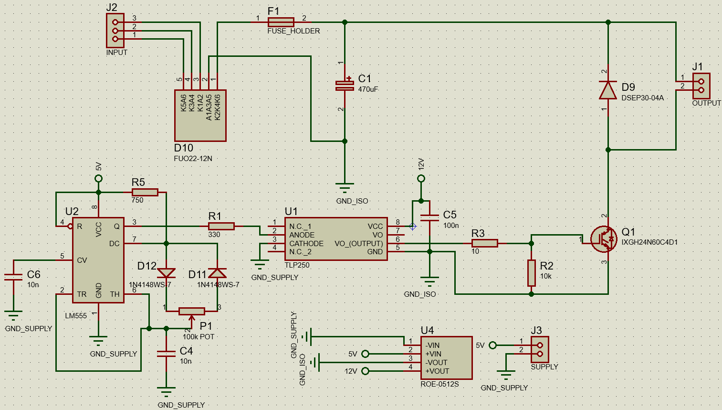

Figure x. The PCB schematic.

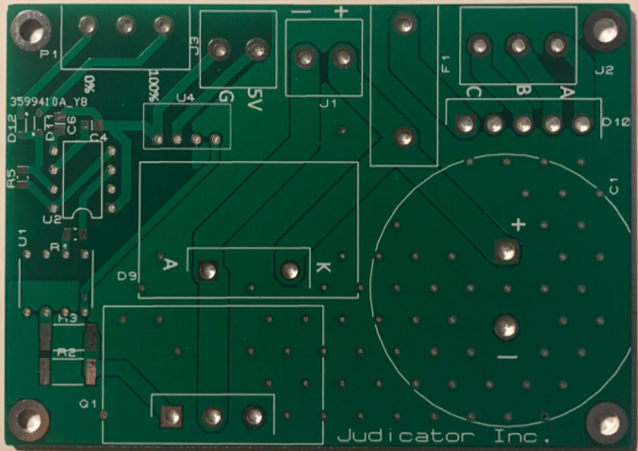

Figure x. The physical PCB layout.

metin, elektronik eşyalar, beyaz içeren bir resim

Açıklama otomatik olarak oluşturuldu

Figure x. The case of the final product.

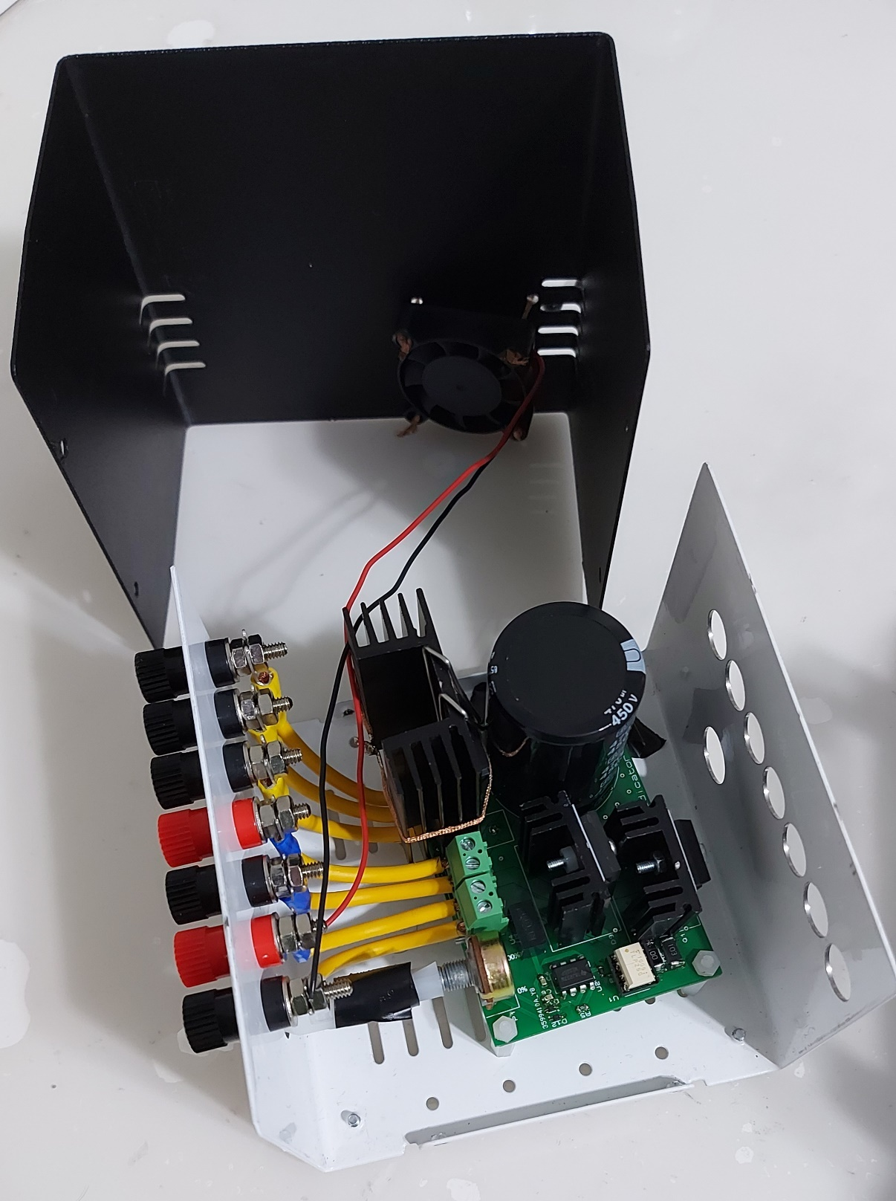

Figure x. Inside view of the final product.

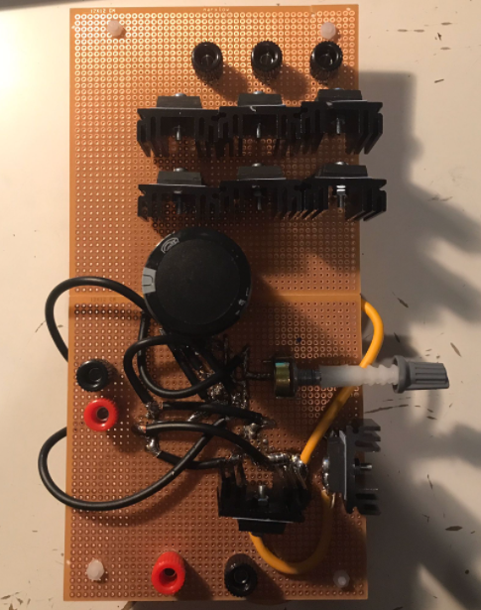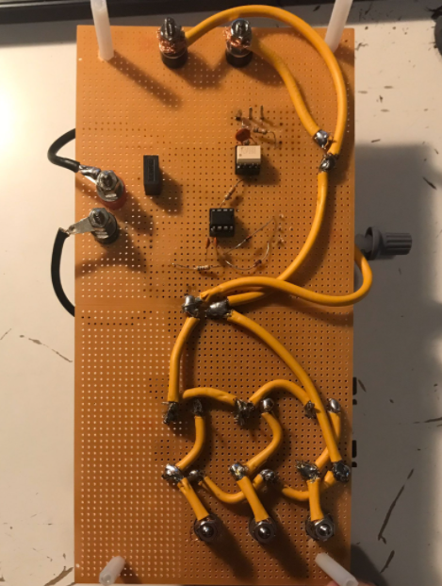

Figure x. The pertinax layout.

For the pertinax design, 45AS25 heatsinks were appended to the individual rectifier diodes, the IGBT, and the freewheeling diode. For the PCB design, heatsinks were placed on the bridge rectifier, the IGBT, and the freewheeling diode.

With the placement of the capacitor at the output of the three phase rectifier, the AC signal was converted into a low ripple almost-DC signal.

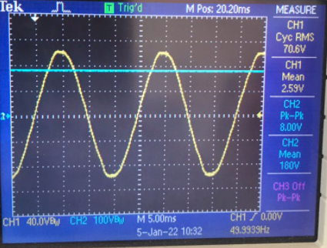

Figure x. The rectifier output.

The rectifier output voltage appears higher than the theoretical $\frac{3\sqrt{6}}{π}V_{ph,rms}= \frac{3\sqrt{6}}{π}×70V_{rms}=165.14V$, at 180V. This is made possible with the DC link capacitor. Accordingly, the percentage ripple turns out to be,

$$\frac{∆V_{out}}{V_{out}}=\frac{V_{peak-to-peak}}{V_{out, ave}}=\frac{8V}{180V}≅4.44\%$$

We then built the MOSFET gate driver circuit composed of a LM555 I.C. timer whose output’s duty cycle would be determined with a potentiometer. This waveform has a voltage swing of 5V. The output is then sent to the optocoupler TLP250 for electrical isolation, and then stepped up with a boost converter from 5V to 15V so that the IGBT gate can be activated.

The following tests were conducted with a relatively low voltage applied on the collector end (15V) and a resistor connected between the emitter pin and the ground. The yellow trace represents the 555 timer output and the blue trace represents VCE. Effectively, when the output of the timer is high (and by extension, the IGBT gate signal), VCE should be set to a mV-order level (which is the on-voltage drop varying with current). Otherwise, with the switch off, VCE should remain at 15V.

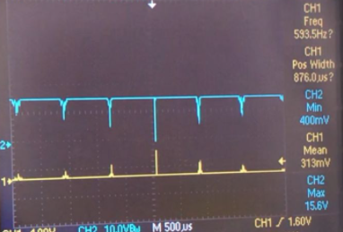

Figure x. The collector-emitter voltage and the gate signal for nearly D=0.

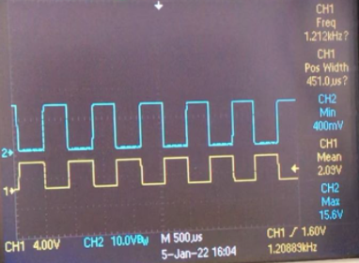

Figure x. The collector-emitter voltage and the gate signal for D=0.5.

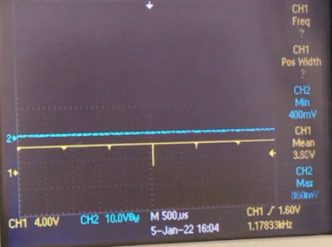

Figure x. The collector-emitter voltage and the gate signal for nearly D=1.

The absence of ringings and oscillations in these waveforms implied no snubber was necessary. Later with R-load and R-L load tests, when there were no such oscillations observed, this implication was confirmed.

# Test Results

**R-load test**: For this test, the resistive load in the lab (configured to be 48Ω) was connected to the output ports.

**RL-load test**: For this test, the resistive load in the lab (configured to be 48Ω) was connected in series with the inductive load (configured to 200mH) to the output ports. In order to test whether the circuit could withstand high load currents, (well above the no-load DC motor’s 3A rating) we wanted to see how long the circuit could operate until the IGBT temperature reached high values (above 120°C). A way to minimize the power dissipation on the IGBT is to decrease the duty. In turn, the output of the buck converter decreases. However, considering there was no strict input voltage limitation on the input end, the reduction in duty could still be compensated by a higher input voltage. This method was reserved for the loaded DC motor test. For the RL load test in the lab, a high duty was used to test the limits of the IGBT.

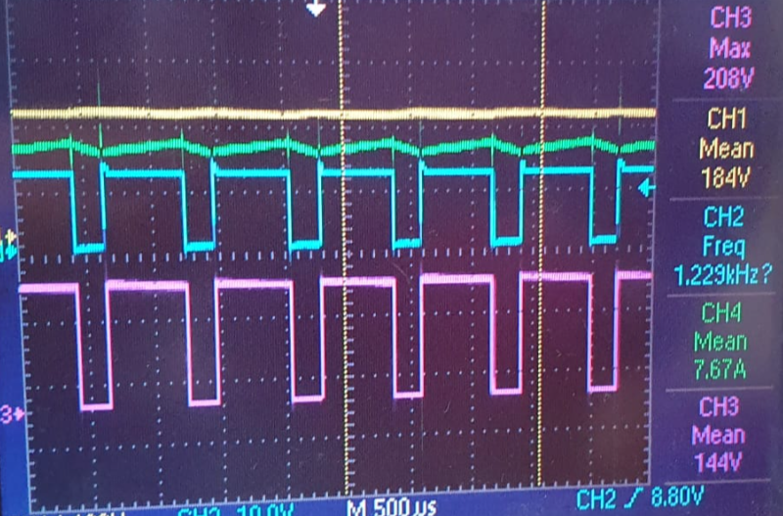

Figure x. The RL-load test results, for a load current of 7.67A.

The yellow trace is the rectifier output voltage, the blue trace represents the IGBT gate signal, the purple trace represents the output voltage, and the green trace depicts output current. Due to the presence of the inductor, the load remains in continuous conduction.

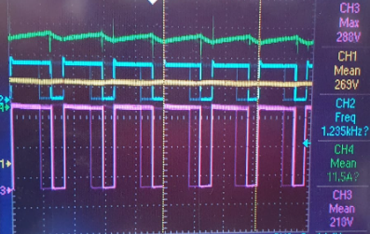

Figure x. The RL-load test results, for a load current of 11.5A.

The input voltage was further increased to see the duration the IGBT could last while delivering a heavy load current of 11.5A. The output voltage mean, at 218V, was higher than the rated 180V of the armature voltage of the DC motor, however, this test was conducted as a preliminary evaluation of whether the circuit could pass the full-load DC motor test.

**No load DC motor test**: The PCB version of the driver was placed to drive the no-load DC motor for 3 minutes, delivering a current of 3A at rated speed.

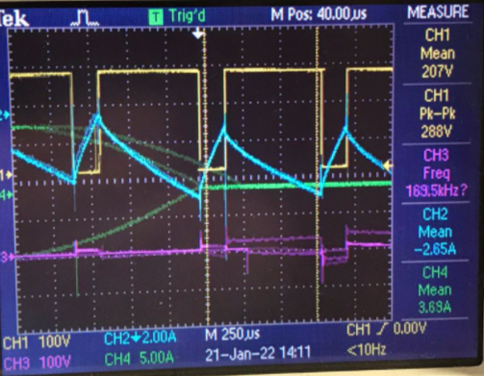

Figure x. The no load DC motor test results.

The yellow trace represents the output voltage and the blue trace depicts the output current.

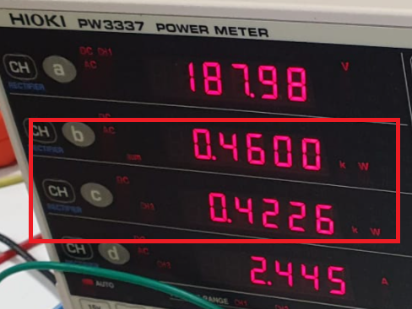

Figure x. The input and output power measurements.

Accordingly, an efficiency of 91.87% was recorded.

**Kettle loaded DC motor test**: The PCB version of the driver was placed to drive a motor whose load was a generator supplying power to an electric kettle (2kW) boiling tea. Here, external cooling was conducted by our team members, cooling the IGBT manually with a fan. During the operation, it was observed that one of the phases appeared open circuited in the rectifier leading (presumably due to an inrush current problem) that led to decreased efficiency.

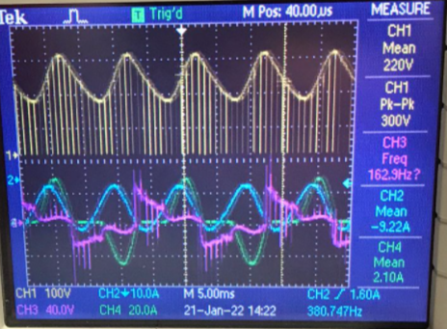

Figure x. The kettle loaded DC motor test results.

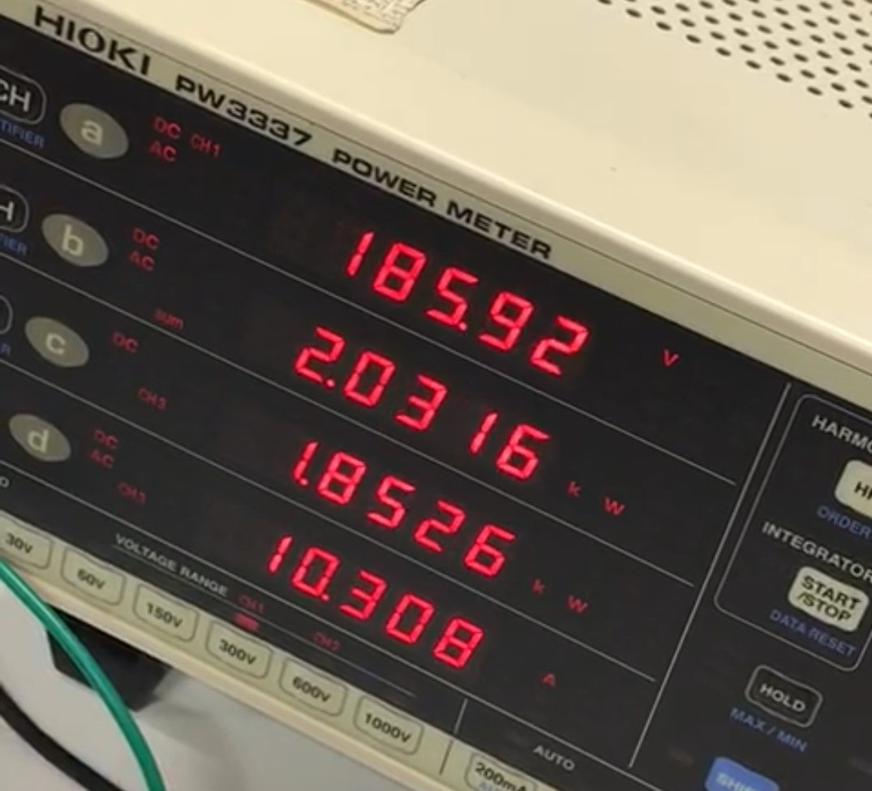

Figure x. The input and output power measurements for loaded case.

kişi içeren bir resim

Açıklama otomatik olarak oluşturuldu

Figure x. The input and output power measurements.

As seen in Figure X, IGBT was heated to 63.7°C. However, this was not the final value we observed during loaded operation. Actually, IGBT was heated to around 140°C at the end of the demonstration due to the lack of one of the phases and using insufficient fan, but we could not capture it since we were dealing with that heating problem.

# Cost Analysis

|  |  |  |
| --- | --- | --- |
| Component | Unit Price | Amount |
| PCB | $0.4 | 1 |
| ROE-0512S | $3.51 | 1 |
| 100nF Cap | $0.00429 | 1 |
| 10nF Cap | $0.00988 | 2 |
| LM555 | $0.1415 | 1 |
| TLP250 | $1.219 | 1 |
| Spacer | $0.13033 | 4 |
| Thermal Pad | $0.05318 | 2 |
| Fan 5V | $1.6794 | 1 |
| 100kΩ Pot | $0.1767 | 1 |
| 45AS25 Heatsink | $0.8809 | 3 |
| Metal Box | $6.44329 | 1 |
| IXGH24N60C4D1 | $4.33829 | 1 |
| DSEP30-04A | $1.73536 | 1 |
| 470µF Cap | $3.8996 | 1 |
| 1N4148WS-HT | $0.01903 | 2 |
| M3 Screw-Washer-Nut | $0.0707 | 2 |
| Banana Plug 4mm | $0.38277 | 7 |
| Fork Connector | $0.09614 | 7 |
| Plastic Nut M3 | $0.05185 | 4 |
| Tblock 2-pin | $0.24967 | 2 |
| Tblock 3-pin | $0.37456 | 1 |
| 10Ω 3W Res | $0.22793 | 1 |
| 10kΩ 3W Res | $0.22793 | 1 |
| 750Ω Res | $0.00377 | 1 |
| 330Ω Res | $0.00377 | 1 |
| FUO22-12N | $8.5 | 1 |
| Fuse Holder | $0.08239 | 1 |
| Fuse 30A | $0.04419 | 1 |
| Dowel | $0.00786 | 2 |
|  |  |  |

The total cost of 1 product is $40.556. It is $40556 for 1000 products.

# References

[1] 555 Timer IC: Introduction, Basics and Working with Different Operating Modes. <https://www.engineersgarage.com/555-timer-ic-introduction-basics-working-with-different-operating-modes/>